EXPERIMENT – 4
Create a simple cloud software application for Car Booking Reservation System using any Cloud Service Provider to demonstrate SaaS.
AIM: To create and provide a simple cloud-based software application for Car Booking Reservation System using Zoho Creator to demonstrate the Software as a Service (SaaS) model.
PROCEDURE:
- Open a web browser and go to Zoho Creator website.
- Create a Zoho account and log in.
- Click on Create Application and select From Scratch.
- Choose Blank App and provide the application name as Car Booking Reservation.
- Create a form named User Details and add fields such as Name, Phone, Email and Saved address.
- Create another form named Book a Cab and add fields such as Name, Phone, Email, Number of Passengers, Booking date, Travel date, Pickup Address and Destination Address.
- Add map-based location pinning for coordinates for addresses.
- Mark the necessary fields as mandatory.
- Save the completed form and alter the visual themes.
- Configure user access and sharing settings to allow multiple users to use the application.
- Save the application and generate the application URL.
- Access the application through the URL using any web browser.

OUTPUT: 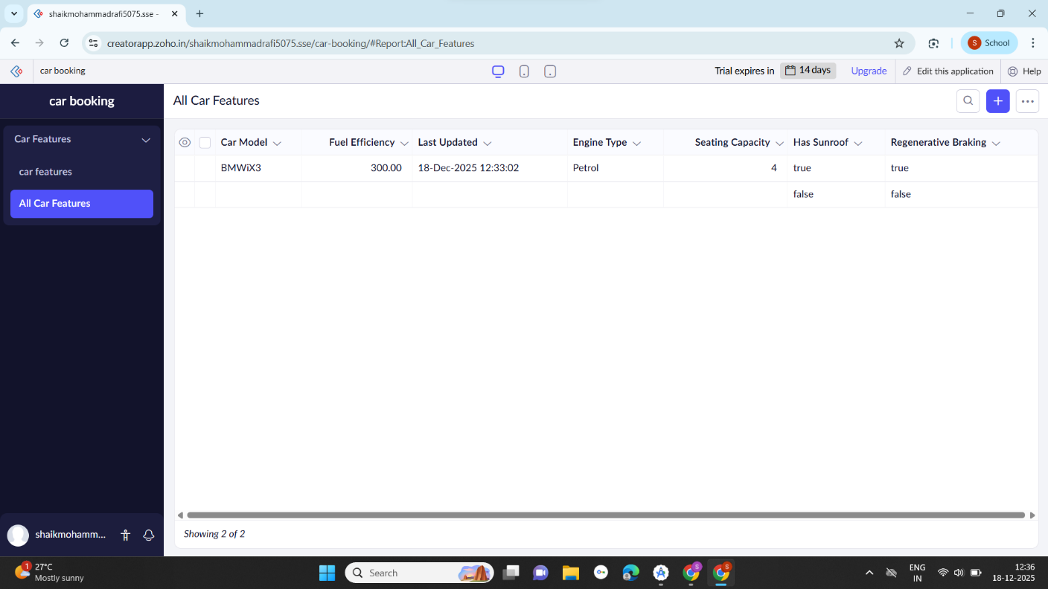

RESULT:
A cloud-based Car Booking Reservation System application was successfully created and deployed using Zoho Creator. The application is accessible through a web browser without installation, and users can Sign up and book a car, thereby successfully demonstrating the Software as a Service (SaaS) model.

